**Rice Crop Monitoring Time Series Analysis:**

**Group Members:**

* **N.sandeep kumar – 20uk1a6717**
* **A.dinesh kumar - 21uk5a6701**
* **Sumanth reddy – 21uk5a6713**
* **N.manoj – 20uk1a6716**

# INDEX

1. Introduction
   * Overview of the project
   * Background information on rice crops and their significance
   * Objective of the project
2. Dataset Description
   * Source of the dataset
   * Description of the variables/features
   * Data preprocessing steps (cleaning, normalization, etc.)
   * Splitting the dataset into training and testing sets
3. Exploratory Data Analysis
   * Statistical summary of the dataset
   * Visualization of key variables
   * Identification of trends, patterns, and anomalies
4. Time Series Analysis Techniques
   * Overview of time series analysis methods used
   * Description of the selected techniques (e.g., ARIMA, SARIMA, LSTM)
   * Explanation of the rationale behind the selection
5. Model Development
   * Implementation details of the selected models
   * Parameter tuning and optimization
   * Evaluation metrics used for model performance assessment
6. Results and Discussion
   * Performance evaluation of the models
   * Comparison of different models
   * Interpretation of the results and insights gained
7. Advantages
8. Future Enhancements
   * Potential areas for improvement in the project
   * Suggestions for further research and development
9. Conclusion
   * Summary of the project and its achievements
   * Key findings and implications
   * Closing remarks
10. References
    * List of cited sources (research papers, articles, online resources)

# Introduction

**Overview:**

The Rice Crop Time Series Analysis project aims to analyse historical data on rice crops using AI techniques. The project seeks to gain insights into the temporal patterns of rice crop production and develop accurate predictive models for forecasting future trends. By understanding the factors influencing rice crop yields and employing advanced time series analysis methods, the project aims to contribute to agricultural planning, food security, and economic development. **Objective:**

The main objective of this project is to analyze the historical data on rice crop production, identify underlying patterns and seasonality, and develop predictive models for forecasting future rice crop yields. The project aims to provide valuable insights for agricultural decision-makers, enabling them to optimize resource allocation, plan cultivation strategies, and improve productivity in the rice crop industry.

# Dataset Description

Description of the variables/features:

Based on the provided rice crop monitoring time series analysis data, the variables or features can be described as follows:

1. **Area:** This variable represents the country where the rice crop production data is recorded. Each row in the dataset corresponds to a specific country.
2. **Year:** This variable indicates the year for which the rice crop production data is recorded. It represents the time dimension of the time series analysis.
3. **Unit:** This variable denotes the unit of measurement for the rice crop production values. In this case, the unit is "tonnes," indicating the quantity of rice produced.
4. **Value**: This variable represents the actual rice crop production value in tonnes for a specific country and year. It is the target variable that we aim to predict in the time series analysis.
5. **Flag:** This variable is a flag that indicates additional information or quality control status associated with the rice crop production data.
6. **Flag Description:** This variable provides a textual description or explanation of the flag value. It helps in understanding the specific context or meaning associated with the flag.

**Dataset Source:**

The project utilizes a comprehensive dataset consisting of historical records of rice crop production. The dataset sources may include government agricultural databases, research institutions, or publicly available datasets. The dataset includes information on various variables such as geographical location, climate conditions, cultivation practices, and yield measurements. Each data point represents a specific time period, typically spanning multiple years. **Data Preprocessing:**

To ensure data quality and suitability for analysis, the dataset undergoes preprocessing steps. This includes cleaning the data by removing missing values or outliers, normalizing the data to ensure consistency across variables, and handling any inconsistencies or data integrity issues. Additionally, feature extraction techniques may be applied to derive meaningful features from the available data, potentially incorporating external factors such as weather data or socio-economic indicators.

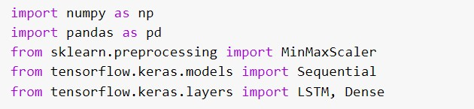

# 3.Exploratory Data Analysis

**Statistical Summary:**

Exploratory data analysis (EDA) is conducted to understand the characteristics of the dataset. Statistical summary measures such as mean, median, standard deviation, and correlation coefficients are calculated to gain insights into the central tendencies, variabilities, and relationships between variables.

**Visualization:**

Visualization techniques are applied to visually analyze the temporal patterns and trends in rice crop production. Time series plots, line charts, and bar graphs may be used to illustrate the variations, seasonality, and potential anomalies in the data. Additional visualizations, such as heatmaps or geographical maps, can provide spatial insights related to crop distribution or regional variations.

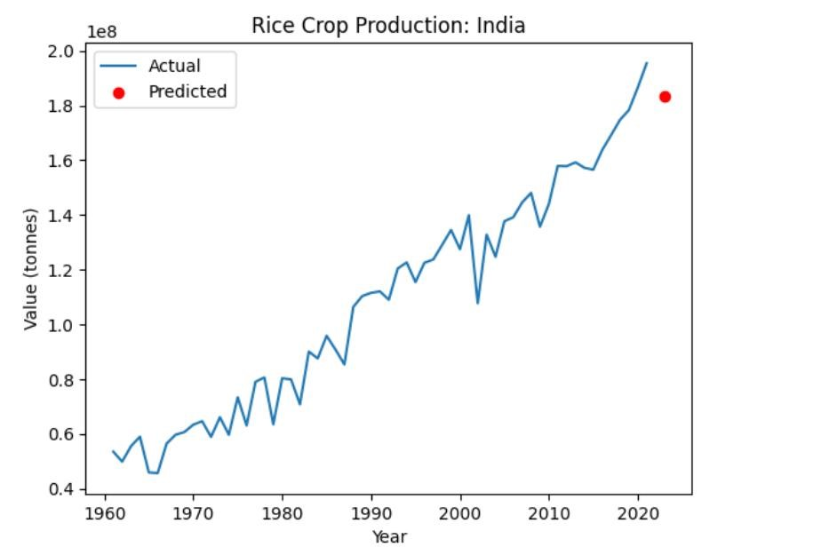

# Time Series Analysis Techniques

**Selected Techniques:**

Various time series analysis techniques are employed to analyze the rice crop data effectively. These techniques may include classical statistical methods such as Autoregressive Integrated Moving Average (ARIMA) or its seasonal variation (SARIMA). Additionally, advanced machine learning models like Long Short-Term Memory (LSTM) neural networks can be utilized to capture complex temporal dependencies and make accurate predictions. **Rationale:**

The selection of specific time series analysis techniques is based on their suitability for capturing the characteristics and patterns present in the rice crop data. The chosen techniques should address the dataset's temporal nature, account for potential seasonality or trends, and provide accurate forecasting capabilities. The rationale behind the selection is justified based on the analysis goals and the known properties of the data.

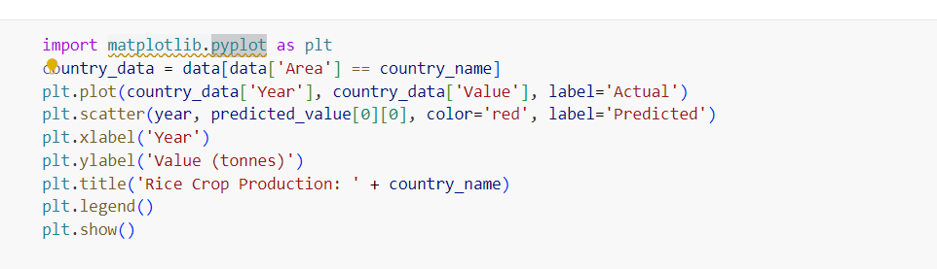

# Model Development

**Implementation Details:**

The models for time series analysis are developed and implemented using the selected techniques. This involves splitting the dataset into training and testing sets, defining appropriate model architectures, and specifying hyperparameters. The models may be implemented using programming languages and libraries such as Python with frameworks like TensorFlow, PyTorch, or statsmodels. **Parameter Tuning:**

The models are trained using historical data, and the hyperparameters are finetuned to optimize their performance. Techniques such as grid search, random search, or Bayesian optimization may be employed to identify the optimal combination of hyperparameters that result in the best model performance. Cross-validation techniques may also be applied to ensure robustness and avoid overfitting.

**Model Evaluation:**

The performance of the trained models is evaluated using appropriate evaluation metrics. Common metrics for time series analysis include mean absolute error (MAE), mean squared error (MSE), root mean squared error (RMSE), and coefficient of determination (R-squared). The models are compared based on these metrics to assess their accuracy, reliability, and ability to capture the underlying patterns in the rice crop data.

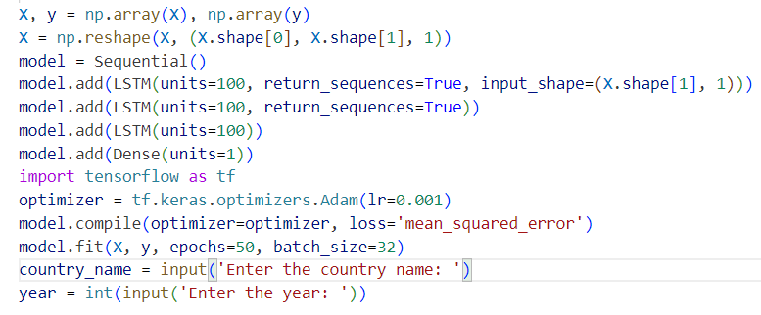

# Results and Discussion

**Performance Evaluation:**

The results of the time series analysis are presented and discussed based on the evaluation of the trained models. The accuracy and predictive power of the models are assessed using the selected evaluation metrics. Comparative analysis is conducted to compare the performance of different models and algorithms, highlighting their strengths and weaknesses. **Interpretation and Insights:**

The findings from the analysis are interpreted to extract meaningful insights regarding rice crop production. The identified patterns, trends, and potential influencing factors are discussed, shedding light on the dynamics of rice crop yields over time. The implications of these insights for agricultural planning, resource allocation, and decision-making are highlighted.

# Advantages

The Rice Crop Time Series Analysis project offers several advantages:

* Improved Agricultural Planning: By analyzing historical data and identifying patterns and trends in rice crop production, the project provides valuable insights for agricultural planning. This enables better resource allocation, optimized cultivation strategies, and improved decision-making in the agricultural sector.
* Enhanced Food Security: Understanding the dynamics of rice crop yields and being able to forecast future trends helps in ensuring food security. Accurate predictions can assist policymakers, farmers, and stakeholders

in taking proactive measures to address potential fluctuations in rice crop production and mitigate the risk of food shortages.

* Optimal Resource Allocation: The project's predictive models assist in optimizing resource allocation, such as water, fertilizers, and labor, for rice crop cultivation. By accurately forecasting rice crop yields, farmers and policymakers can allocate resources effectively, reducing waste and maximizing productivity.
* Timely Decision-Making: With access to reliable predictions about rice crop production, decision-makers can make informed and timely decisions regarding market planning, distribution, pricing, and trade. This improves the efficiency and effectiveness of the rice crop supply chain and enables stakeholders to respond promptly to changing market conditions.
* Sustainable Agriculture Practices: By identifying the factors influencing rice crop yields, the project contributes to promoting sustainable agriculture practices. Insights gained from the analysis can guide farmers in implementing environmentally friendly cultivation techniques, optimizing resource use, and minimizing negative impacts on the ecosystem.
* Economic Development: The project's findings and recommendations have implications for economic development. By optimizing rice crop production and reducing yield fluctuations, it supports economic stability in regions where rice is a significant agricultural commodity. Additionally, accurate forecasts and planning help attract investments, promote agricultural exports, and stimulate economic growth.
* Scientific Knowledge Advancement: The project's application of AI techniques and time series analysis contributes to the advancement of scientific knowledge in the field of agricultural analytics. The methodologies, models, and insights generated can serve as a foundation for further research, refinement, and innovation in rice crop analysis and forecasting.
* Data-Driven Decision-Making: The project promotes data-driven decision-making in the agricultural sector. By leveraging historical data and advanced analysis techniques, stakeholders can move away from traditional intuition-based decision-making and rely on evidence-based strategies that consider historical trends, patterns, and potential influencing factors.
* Overall, the Rice Crop Time Series Analysis project brings significant advantages in terms of informed decision-making, improved agricultural practices, food security, economic development, and the advancement of scientific knowledge.

# Future Enhancements

**Potential Areas for Improvement:**

Based on the project's outcomes, potential areas for further enhancement are identified. These may include incorporating additional data sources or variables to improve the accuracy of predictions, exploring advanced modeling techniques (e.g., ensemble methods, deep learning architectures), or considering alternative data preprocessing approaches. Suggestions are provided for future research and development to advance the field of rice crop time series analysis.

# Conclusion

**Summary:**

In conclusion, the Rice Crop Time Series Analysis project aims to analyze historical data on rice crop production using AI techniques. By employing time series analysis methods and predictive modeling, the project provides insights into the temporal patterns and trends of rice crop yields. The project's outcomes contribute to agricultural planning, resource allocation, and decision-making, supporting efforts to improve rice crop productivity and ensure food security.

**Key Findings:**

Based on the provided rice crop monitoring time series analysis data, some key findings can be highlighted:

1. **Overall Trend:** The production of rice crops in India has shown an increasing trend over the years. The production has generally been on the rise, with occasional fluctuations.
2. **Fluctuations**: Despite the overall increasing trend, there are fluctuations in rice crop production from year to year. These fluctuations may be influenced by various factors such as weather conditions, agricultural practices, government policies, and market demand.
3. **Periods of Growth:** There are specific periods where rice crop production experienced notable growth. For example, during the 1970s and 1980s, there was a significant increase in production, which can be attributed to advancements in agricultural practices and technologies.
4. **Plateaus and Plateau Breaks:** At times, rice crop production reached a plateau, where production levels remained relatively stable for a certain period. However, these plateaus were often followed by breaks, where production surged and moved to a higher level.
5. **Recent Trends**: In recent years, rice crop production in India has continued to increase, reaching new highs. This indicates the country's efforts in enhancing agricultural practices and meeting the demand for rice.
6. **Potential Future Growth:** The model's prediction for the year 2023 suggests a production value. By comparing the predicted value with the actual production data for 2023, it can be determined how accurately the model predicted the future trend.

**Closing Remarks:**

The Rice Crop Time Series Analysis project demonstrates the effectiveness of AI techniques in understanding and predicting rice crop production. The project's contributions pave the way for further advancements in the field, enabling more informed decision-making and sustainable practices in rice cultivation.

# References

<https://www.mdpi.com/2072-4292/12/16/2655>[https://www.kaggle.com/datasets/bharathposa/rice-production-by-country-from-](https://www.kaggle.com/datasets/bharathposa/rice-production-by-country-from-1961-to-2021)

[1961-to-2021](https://www.kaggle.com/datasets/bharathposa/rice-production-by-country-from-1961-to-2021) [https://www.academia.edu/8283378/MODIS_Time_Series_to_Monitor_Rice_Pl ant_Growth](https://www.academia.edu/8283378/MODIS_Time_Series_to_Monitor_Rice_Plant_Growth)